HDFS- What and Why:

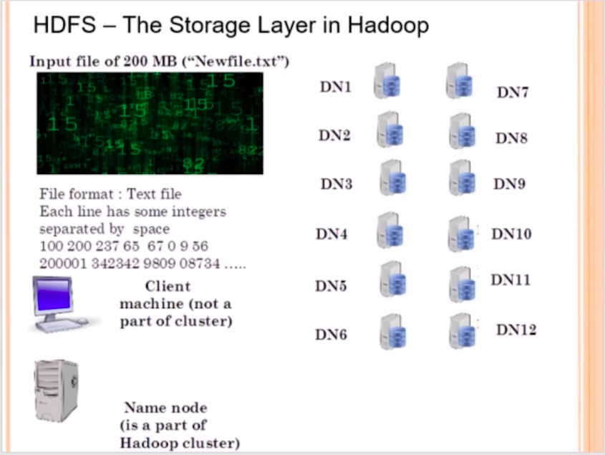

Imagine you have a 1 GB or 2 GB file, and if you want to save that file in your hard-drive, that file will be saved as a single file or a single block. However, In Hadoop, It’s different, Assume that, We have a 200 MB file called as New_file.txt. Since, Hadoop is a distributed File System, which means the 200 MB file will be broken down into smaller blocks of data and it will be distributed across the Data Nodes in the cluster. The file of 200 Mbs will not be save as a single file in one system.

Now as a Analyst, If we are going to submit/push a file into the Hadoop cluster by communicating with the name node. When we install hadoop, there is something called as input file size, which is configured as a system wide parameter by the hadoop administrator. In this case, the input split size will set to be 64 Mbs and for certain reasons it is kept as 64 Mbs and Not less than 64 Mbs. However, at the will of the hadoop administrator, the 64 MB can be increased in multiple of 64, means, you can have split size of 64 MB, 128 MB, 256 MB and so on, but the minimum is recommended to be 64 MB.

Since the input file size is 200 MB and 64 MB is the split size which is global across the Hadoop Cluster set by the Hadoop admin, The input file will be divided into 4 blocks. (N1, N2, N3, N4) and this work is done with the help of the Name Node. And the client machine is the one you are using which is trying to communicate with the name node.

Now, the 4 blocks of data will be stored inside the Data Node, and this job will be done by the Hadoop Distributed File System.
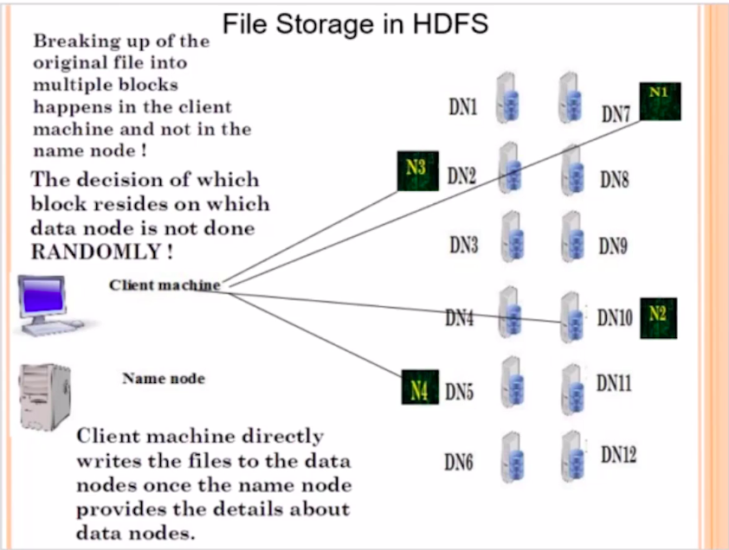

NOTE: The 4 File blocks is not going to be arranged randomly in the Data nodes. There is an algorithm running behind which decides which block has to actually go and sit on which particular data node. The Name node is going to remember where exactly the blocks corresponding to a particular file which we have pushed in the cluster are residing. How big is the block size? What are the host names of the data nodes in which the blocks are present. All these information is going to be present in the form of File Table (FS Image). Which is going to be maintained in the name node.

The name of the File Table is called as (FS Image) . FS stands for File System Image. Assume the FS page as the contents/index page of a book. Similarly, FS Image is the table which remembers, where the blocks of the original file are actually going to be stored.

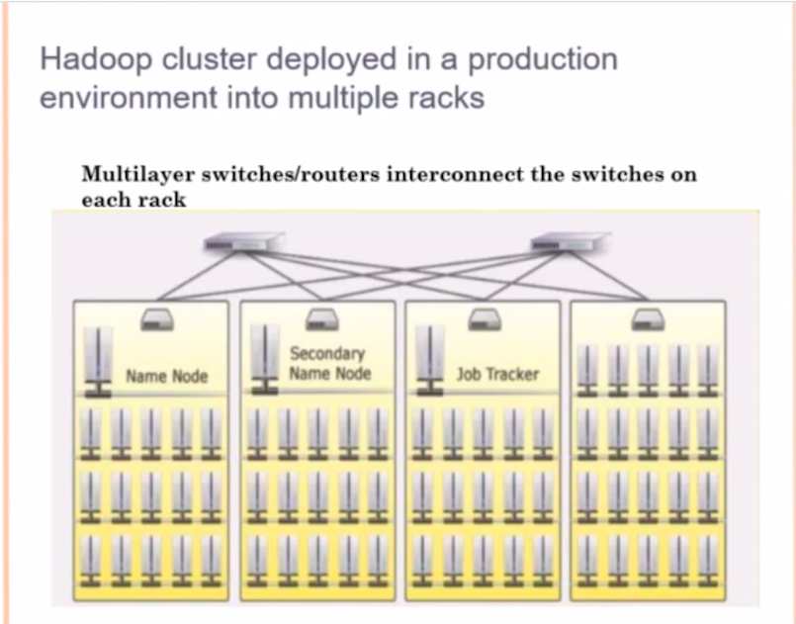

Notice that the Name Node, Secondary Name Node and the Job Tracker are kept in a different rack,
because, in case a single rack failed then all the servers will go down at once. To avoid this, it’s a good practice to have different servers across different racks. And the typical industry standard is to have 20-30 data nodes per rack.

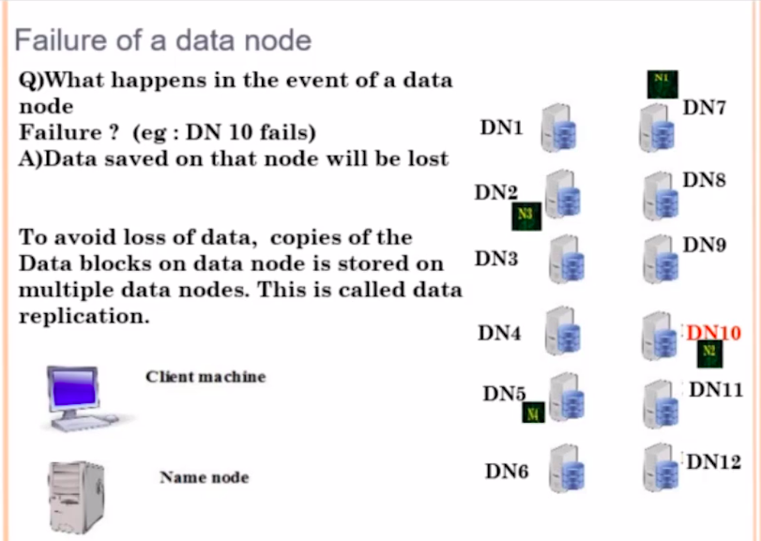

What if the Data Node (DN10) Fails, It means that our file is know corrupted. And here we are talking about big data file. Even if one small block of data is corrupted, the whole data is lost. So, to prevent this kind of a failure, we replicate these blocks, so by default every block in the HDFS is replicated 3 times. So, if your original file is occupying 1 PB of data, than in Hadoop cluster it occupies 3 PB of data. And we cannot change it, because fail over and recovery is more important than occupying the hard-disk space.

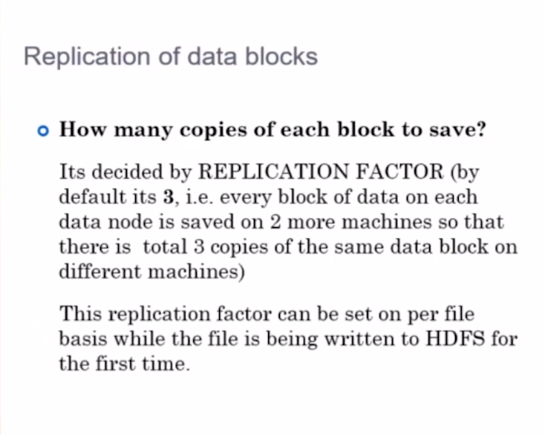
This is called as the replication factor, Which is configured across the system. System wide
replication factor is said to be 3. Now, you can ask a question like, what if we have a replication factor of two, yes you can have it, but not recommended. You can also have a replication factor of greater than 3, but it will occupy too much of space. So, the optimal size is 3. Which is a system wide parameter. Which the system admin will configure while installing hadoop. You as a developer don’t have to worry about these things. You just have to know that every block of data in HDFS is going to be replicated 3 times.

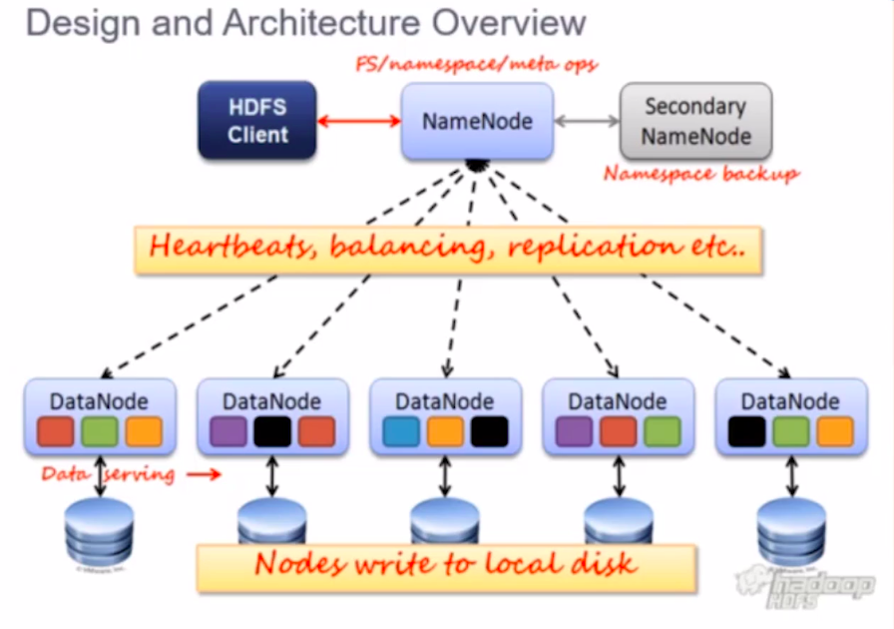

Remember, every data node is sending a Heart Beat signal to the name node. In case, if the data node fails to send a heartbeat signal withing 3 seconds, the Name node assume that the data node is down. So now the replication is 2 copies, the Name node will then raise an system wide alarm to copy the blocks from the neighboring node, to restore the replication factor of 3 across the cluster for the blocks.

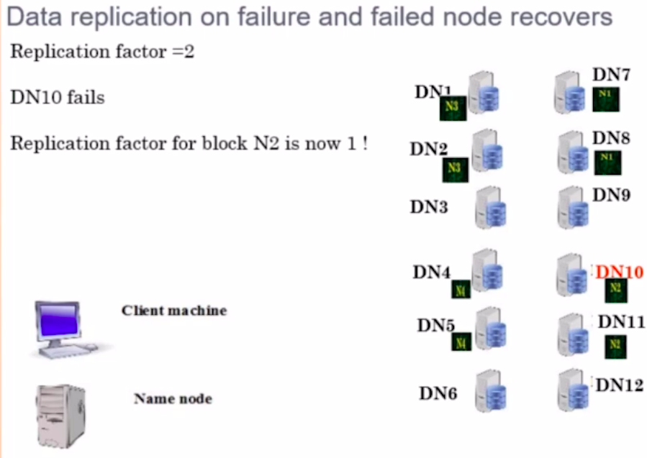

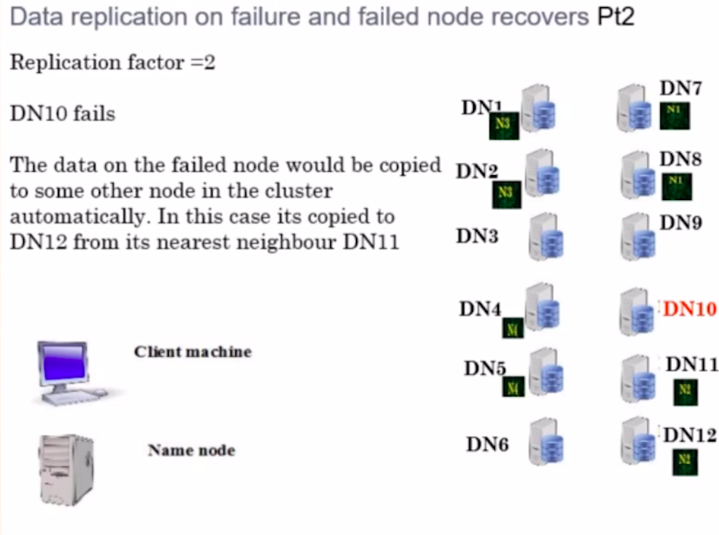

This actually solve the problem of automatic failover and automatic recovery.

Now what if the Data Node (DN 10) is up and running again.
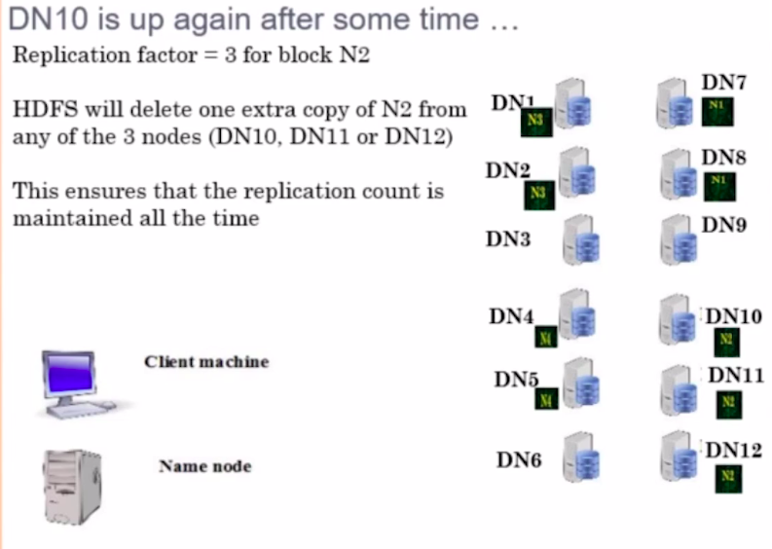

Now, the replication factor is actually 2, but for N2 , there are 3 Blocks, so the Name Node will delete a random N2 block from the cluster. To make sure that every block is replicated 2 times in the cluster.

